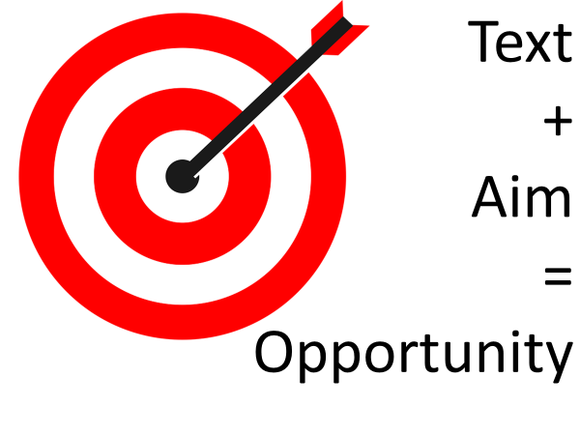
USE THE RAS: RETICULAR ACTIVATION SYSTEM – CREATE AWARENESS

Identify the text | ideally everyone has access to a copy – could be actual text/video/part of your lecture printout/image/poem…
Identify the aim | start with “I really want everyone to get THIS/approach THIS WAY (insert idea) out of this text” and refine it to a short sentence
Advertise this aim | write it up on the board, have it written on a poster and stick it up. This is called ‘making a task retrievable’ (eliminates questions to repeat!!)
Explain the process | See below
Ask for clarifying questions | Keep this short
Play/perform/read through/examine the text | People will be free to make notes about the points and start answering the question
Allow thinking time | Silent and advertised. 1-minute means 1 minute.  Explain that we are giving the gift of silence to each other.
Launch collaborative thinking device | Thinking done, you can pair/share
Sounds a bit like…

“You're about to hear part of a lecture on …..
Please look out for
- 3 reasons why…
- 4 points to explain….
- 2 ideas that are new to you…

At the end of the reading/lecture/video we will be discussing this question:
- What impact does this idea have on the understanding of…..?
- What connections can I make with my own faith experience?
- How does this text support our findings from…?
- To what extent is it…?

Please take notes during the lecture/video/PowerPoint….
We will have 1-minute silent thinking time at the end to allow people to gather their thoughts about the question. THINK
Then we will get together in pairs to test out our ideas. PAIR
Then we will have a class discussion of the main question. SHARE

Value add:
Use the opportunity – all that rich thinking means brains are ripe for a creative/solution finding / designing activity.
- What does this mean for the community of…?
- In groups, draft a response that considers this…
- In what ways could this idea be presented to engage a modern, secular audience?

